### User Manual

**GUI Application:** Private To-Do’s

**GitHub Repository:** <https://github.com/ViviCarta/To-Do-App.git>

**Purpose:** This application is to enhance productivity, improve time management, and help users keep track of their tasks by segmenting their goals into attainable activities. This will also allow users to keep their to-do lists private by associating each to-do list with a single user account.

**1. Login Window**

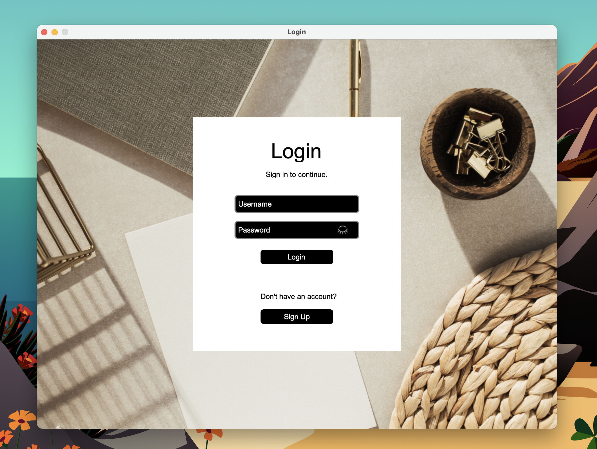

First-time users will have to interact with the Login window at the start before being able to use the main application. There are corresponding entry fields for username and password to input valid user data. After entering a valid user account and clicking the “Login” button, the main application window will display.

**Note: All buttons will show a different color when hovering over them. Also, windows are non-resizable.**

Username and Password details must be valid in order to log in to the main application. In the password field, the “eye” icon can be used to show or hide passwords.

**Note: Example account details below are the default user account for the program.**

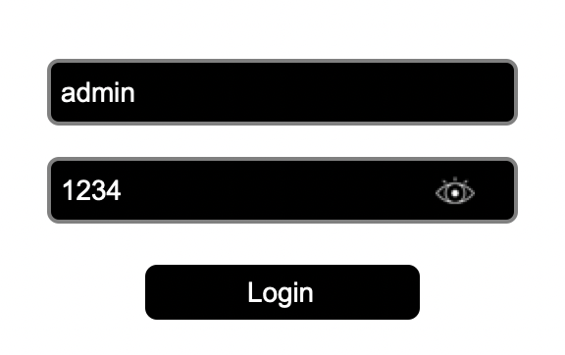

If the user enters an invalid user account, leaves the required entry fields empty, or made a typo, an error dialog box will pop up.

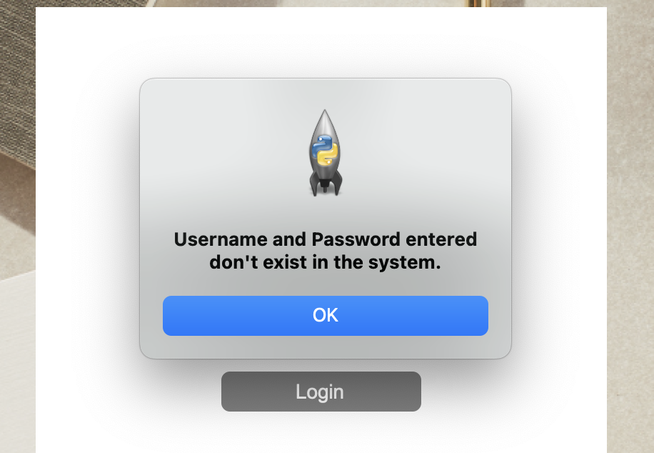

In order to log in with a valid account, users must click the “Sign Up” button located below the “Login” to be redirected to the Sign Up window, where they can create a new account.

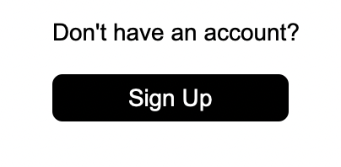

**2. Sign Up Window**

After clicking the “Sign Up” button, users can create a new account by supplying information in all the required entry fields. Once done, an information dialog box will pop up on the screen to announce to the user that their account has successfully been created.

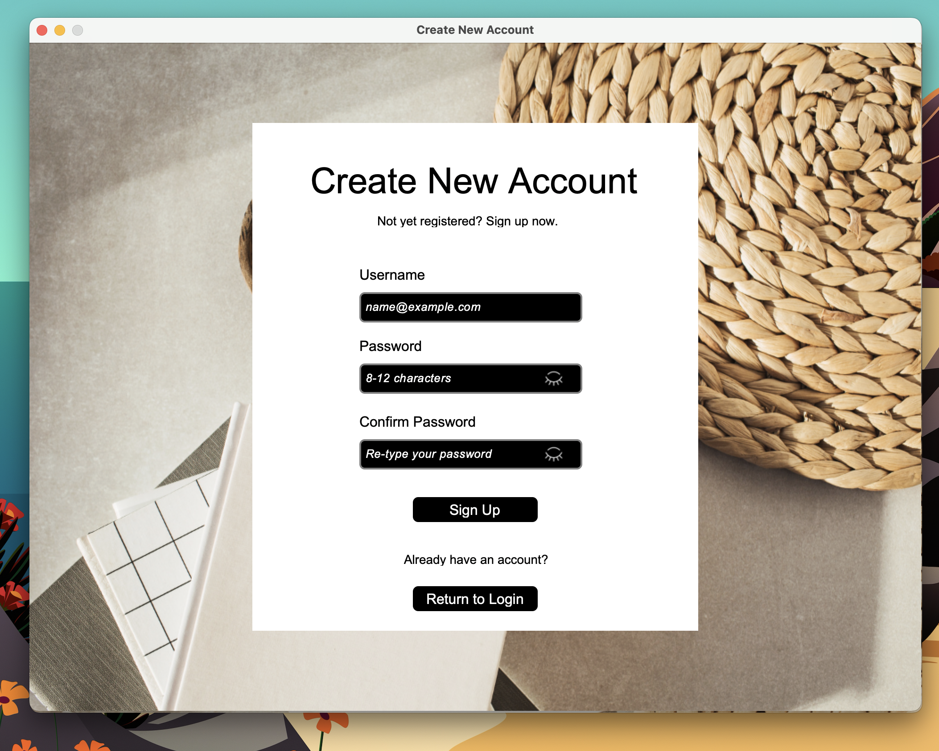

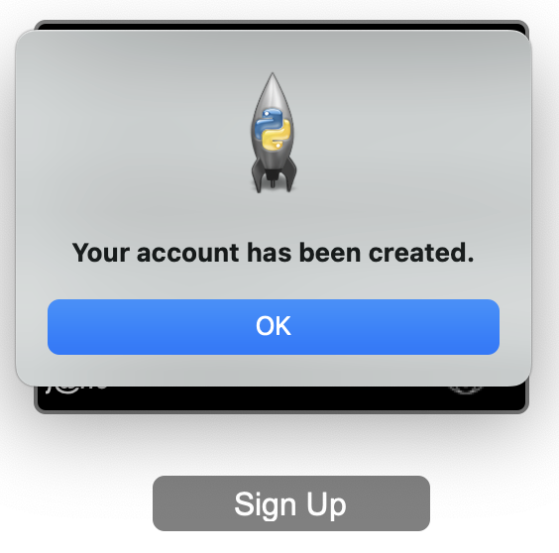

If the user fails to provide information or enters incorrect data for a field, corresponding error dialog boxes will pop up on the screen. Here are a few examples:

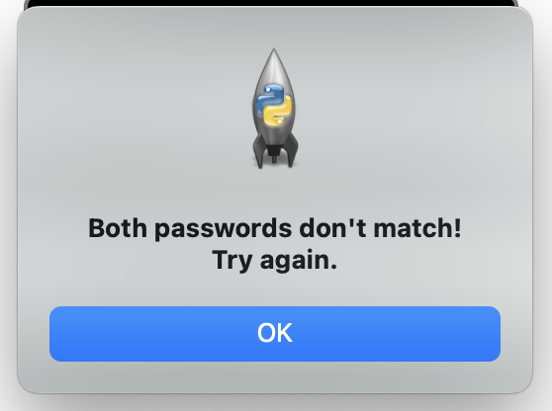

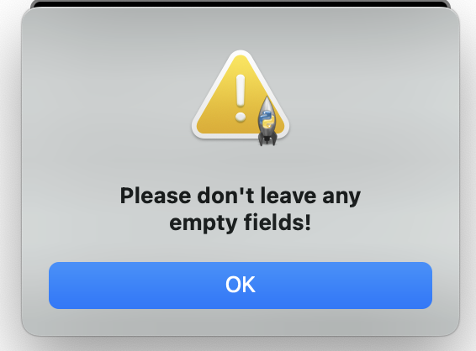

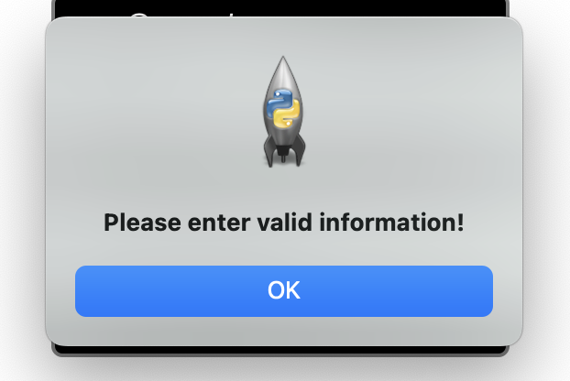

After an account has successfully been created, users can press the “Return To Login” button located below the “Sign Up” button to be redirected back to the Login window and enter their new username and password.

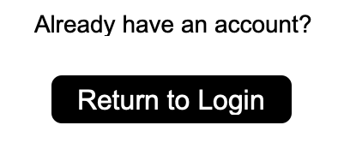

**3. Main Application Window**

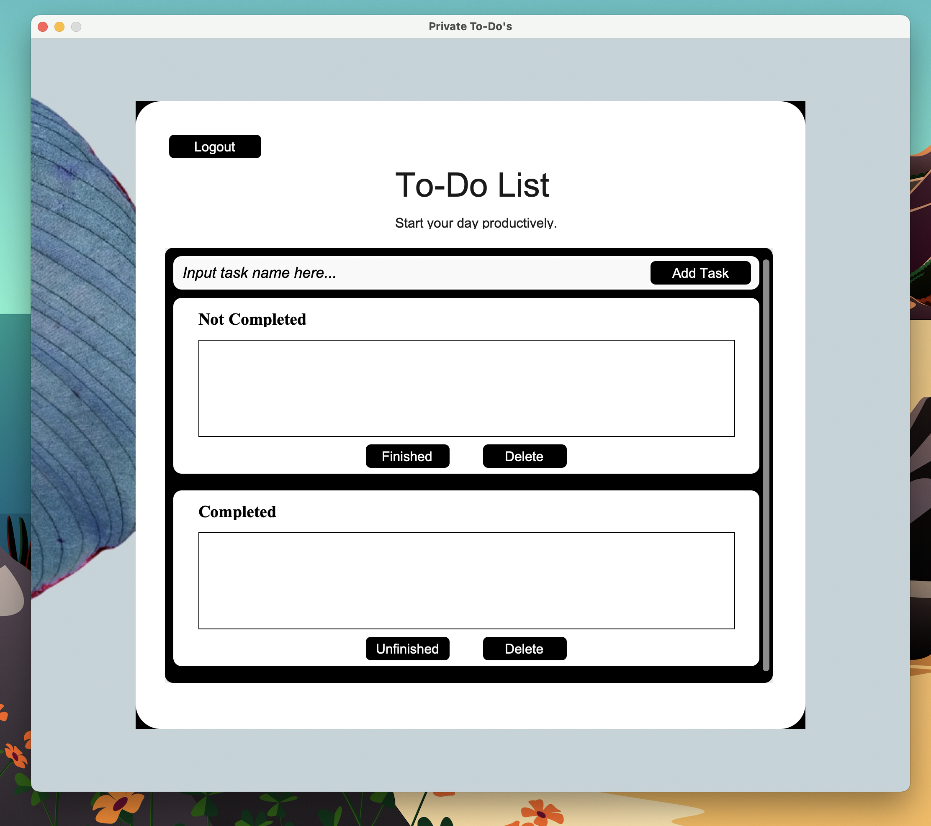

In the main application, users can input their tasks in the entry field with the placeholder text “*Input task name here…*”. In order to add the tasks, they will need to click the “Add Task” button found on the far-right side of the entry field.

After adding the task, users will notice that all their tasks will move inside the “Not Completed” category. This is a special feature that indicates that the task added is still pending completion.

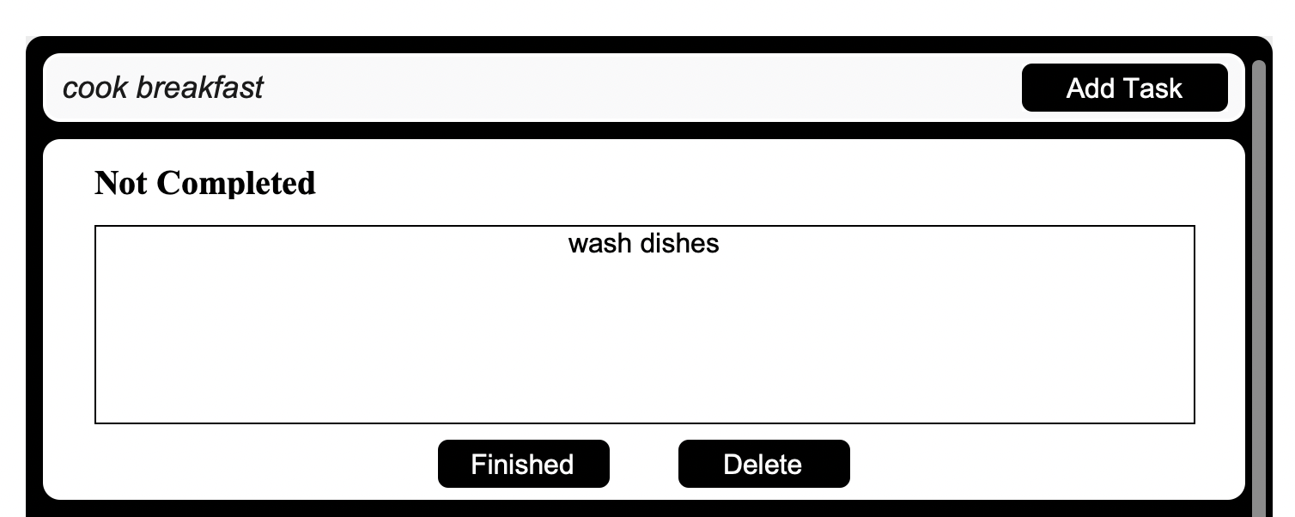

Users can delete the tasks they added within the “Not Completed” category by selecting the specific task and clicking the “Delete” button beside the “Finished” button. A task that is selected will immediately have a different color which will let the user know what task is currently selected.

**Note: You can only use the delete button specified for each category.**

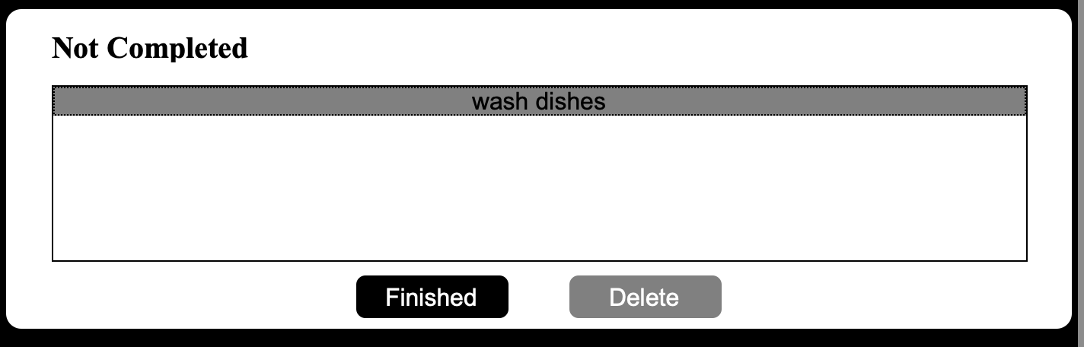

If users are finished with a task, they can move the task under the “Completed” category by simply selecting the task and clicking the “Finished” button.

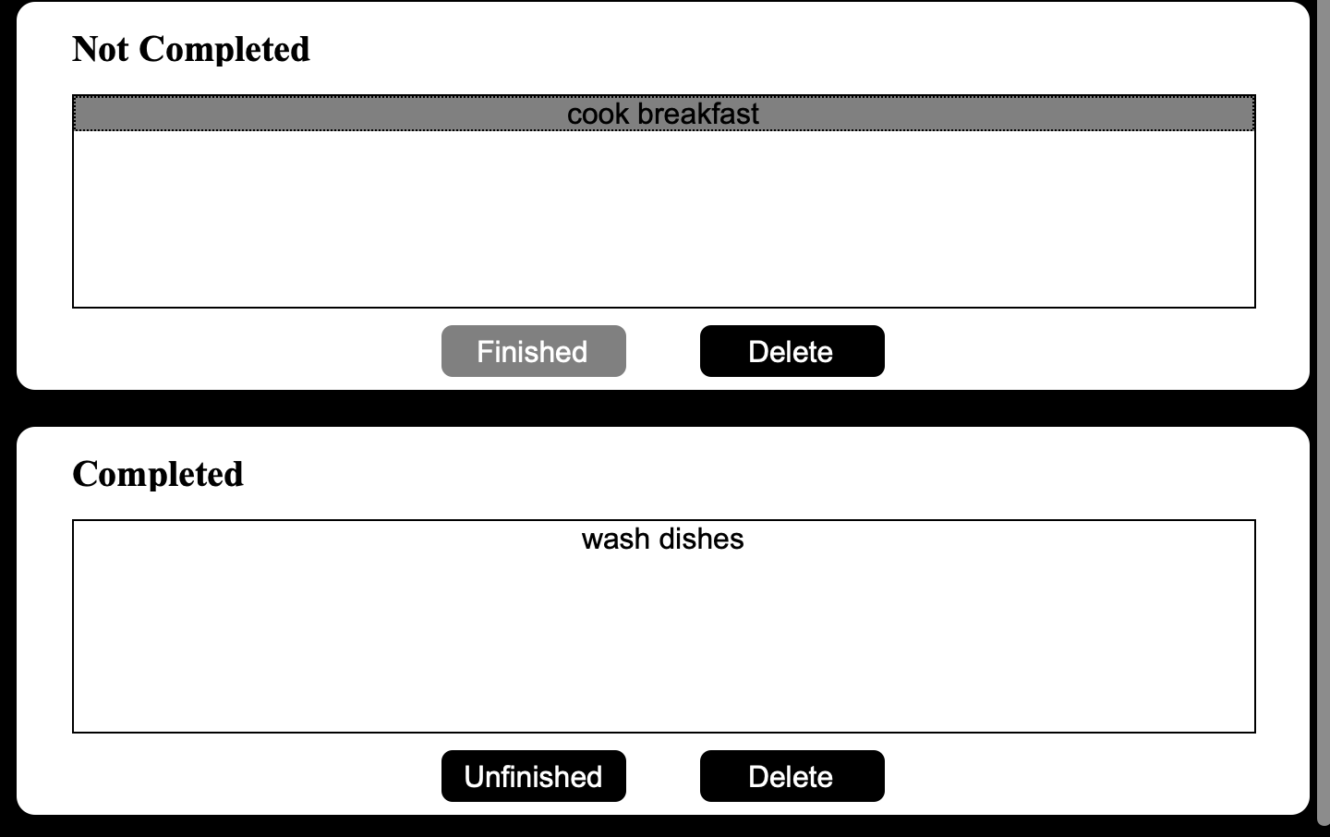

If users want to delete a task inside the “Completed” category, they must select the specific task and make sure to click on the “Delete” button beside the “Unfinished” button.

**Note: You can only use the delete button specified for each category.**

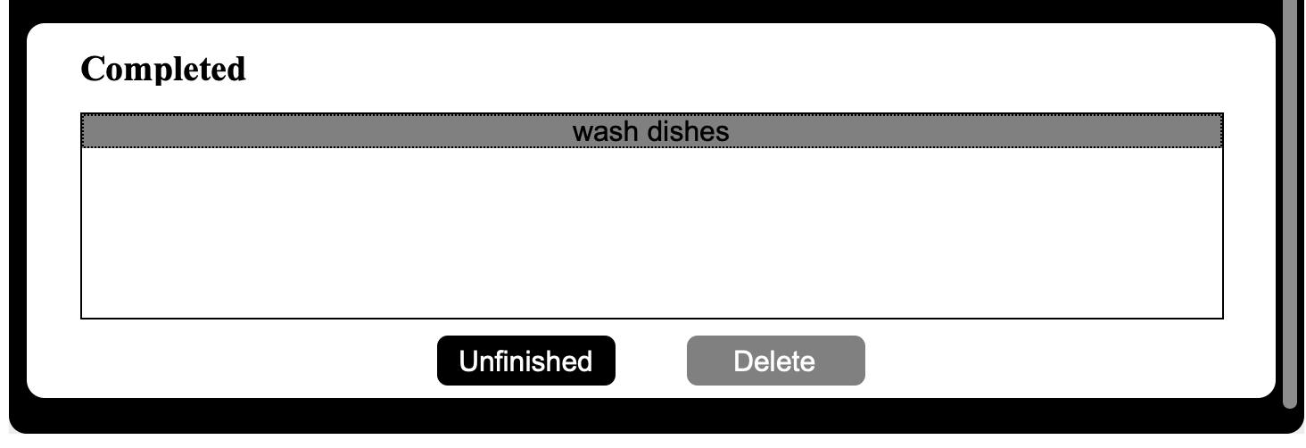

If the users accidentally moved a task to the “Completed” category, they can select the task again and move it back inside the “Not Completed” category by clicking the “Unfinished” button.

**Note: The moved task will show up at the very end of the Not Completed task list.**

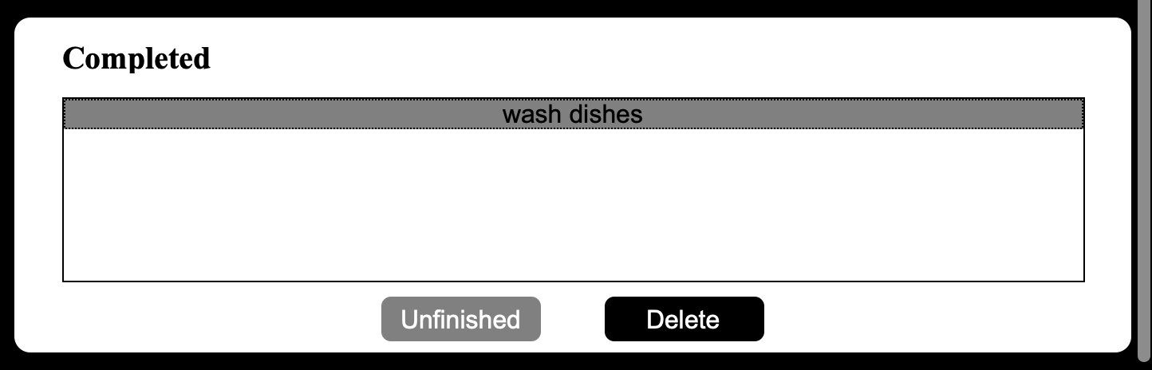

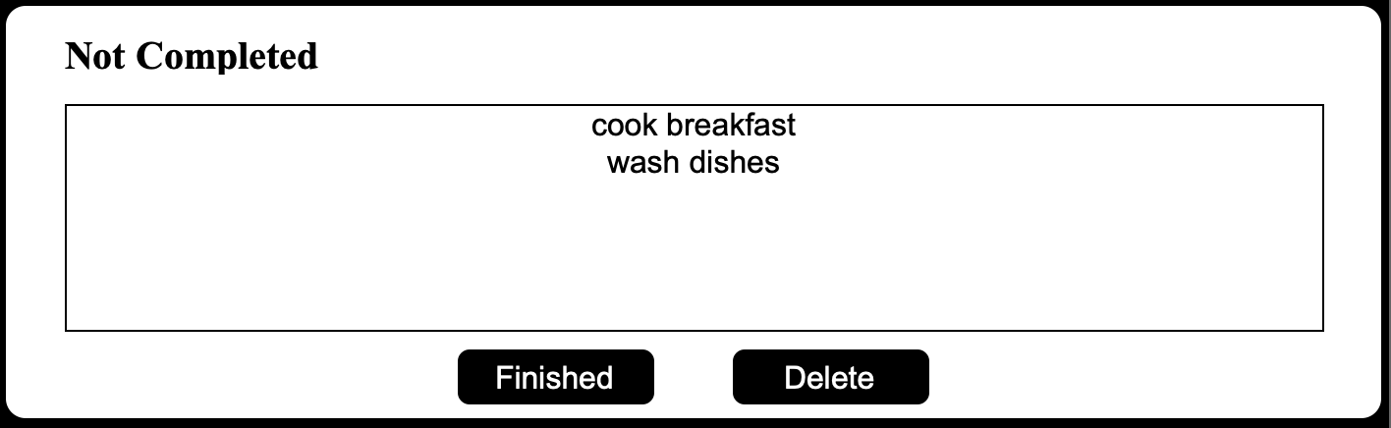

If users have a lot of tasks, they can simply scroll up (either mouse or touchpad) to view the list hidden from view. Make sure to hover over the specific category list first before scrolling up. Below is an example:

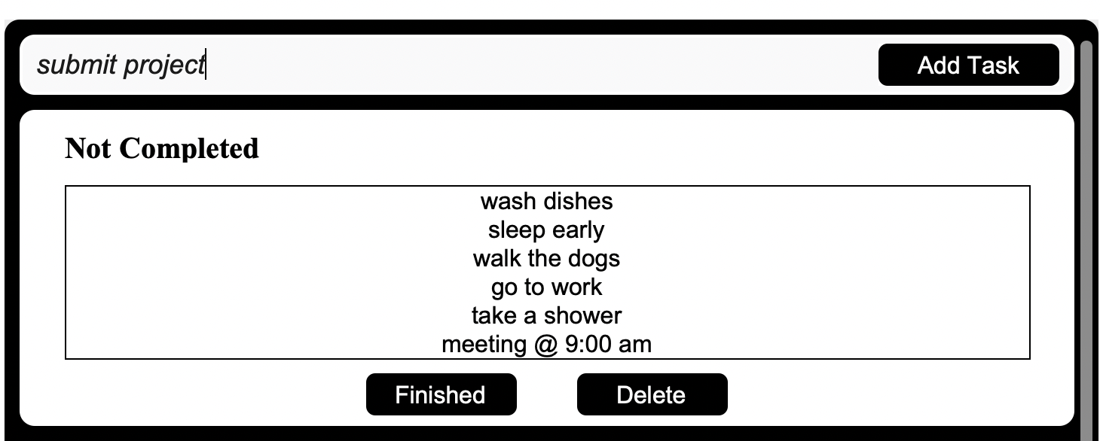

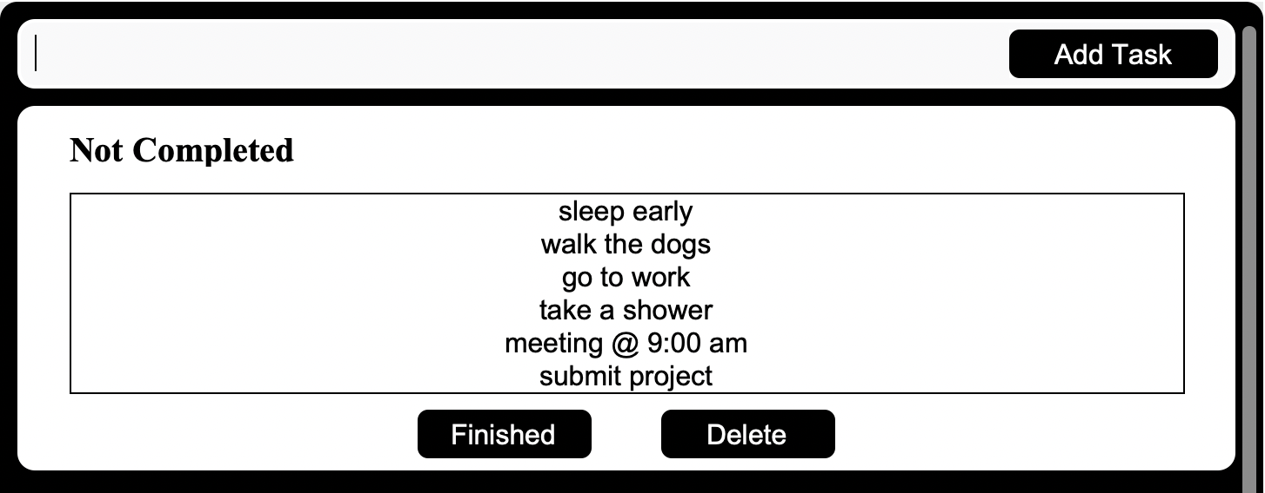

Finally, if users want to close the application, they can click the “Logout” button at the top left to return to the Login window.

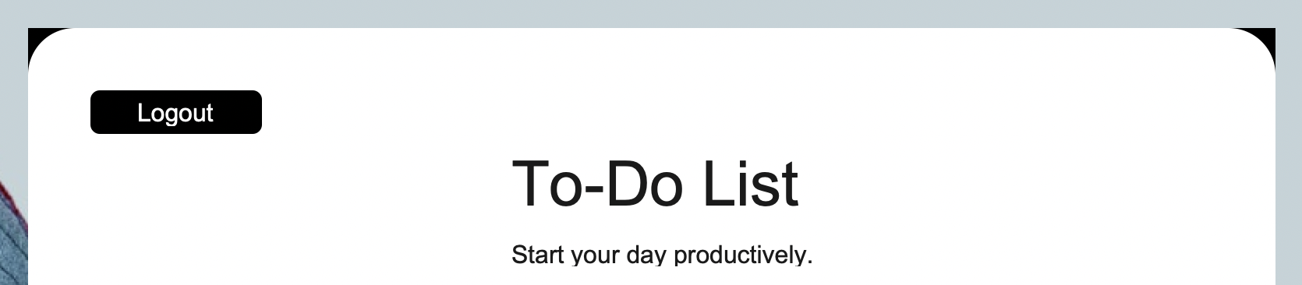

If users want to quit the application, just click the “X” quit button at the top left located in the title bar.

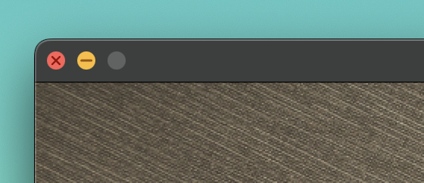

***Developer’s Note: Unfortunately, there is no available function in this program that will save a user’s progress. So, when the user logs out from the application and then logs back in, the application will go back to its default state.***

**3.1 Additional features**

The main application is optimized for light/dark mode. See the pictures below for comparison.



